AP Studio Art Summer Assignment

Mr. Smith

(Bring with you on the second day of AP Art class the following 5 assignments)

Assignment 1 (Supplies):
Art supplies can be found at most art supply stores including- Utrecht, Michael’s, and the U of U Book Store.

- Tackle box (hardware store). You will use your art box to transfer your art supplies to and from the classroom.
- Sketchbook with plain pages 9x 12 or bigger.-doesn’t have to be new.
- Quality colored pencils (Prismacolor)
- Drawing pencils (#2H - #6B)
- Permanent black fine point pen (Sharpie)
- Kneaded Rubber Eraser
- Small box of Watercolors (12-24 colors)
- Acrylic brushes (various sizes)
- Portfolio 18x24 or larger

(10 Points)

Assignment 2 (Hard drive):
Turn in a thumb drive (small hard drive) with your name on it. The thumb drive must have
6 digital photographs on it of past artwork you have done. You should have the three summer assignments #3,#4 & #5 and three other works of art you have created from the past. The photographs must be in focus, so use a tripod to keep the camera steady. And shoot the photographs outside to have correct lighting.
(15 points)

*IMPORTANT: The following art assignments must not be smaller than 10” inches in height or width. That means a drawing 9” x 12” will not be accepted.

Assignment 3 (Still-Life):
Set up a still life of a variety of 2-4 glass bottles. Think about choosing bottles/jars that are a variety of shapes and values. In pencil, draw the still-life as accurately as possible. Pay attention to the shapes you see in the bottles, i.e. do they have hard or soft edges? Are there one or many values in the shape? Shade the drawing paying close attention to creating a wide value range in your drawing from #1(white) through to #7(black). This should be one of your Quality pieces in your AP Portfolio. (The smallest dimension may be no smaller than 10 inches.)
(25 points)

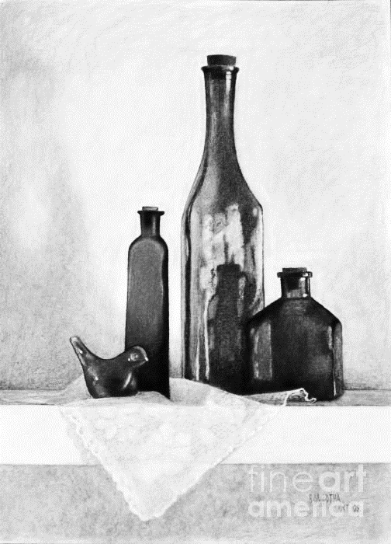

Assignment 4 (Portrait):
Draw or paint an accurate color portrait of yourself using a mirror or photograph from either an unusual viewpoint or with an unusual expression. Pick a color scheme that compliments your pose or expression. You may use colored pencil, paint, pastel or other colored medium. Pay close attention to proportion- use a grid if you like. This should be one of your Quality pieces in your AP Portfolio. (The smallest dimension may be no smaller than 10 inches.)
(25 points)
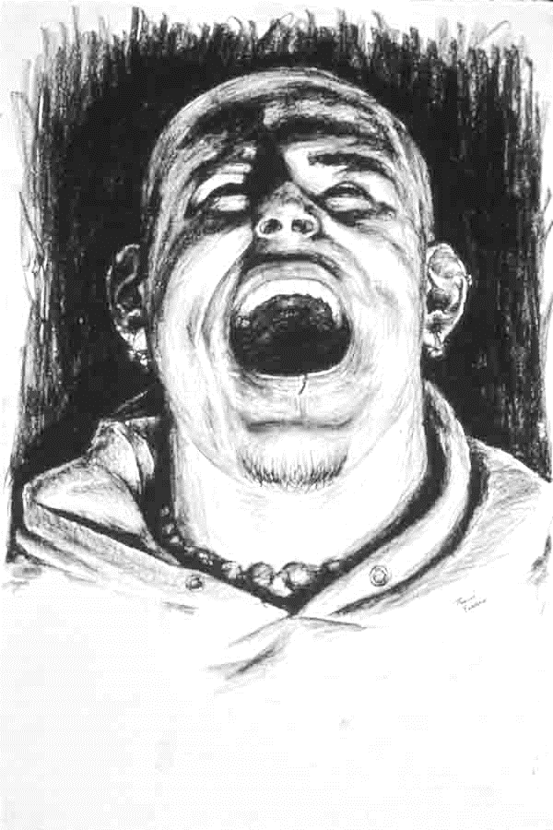

Assignment 5 (Art Historical work):
Using inspiration from a past artist or art movement, create an artwork in the medium of your choosing. Research how other past artist(s) have used your subject matter or media and show their influence in your next piece. You will need to do some research at the library or on line, or go to your local museum for direction. Make it clear to the viewer what/who influenced your art piece. Use your sketchbook to plan the composition of your piece. HINT: Choose a well-known masterpiece. This should be one of your Quality pieces in your AP Portfolio. (The smallest dimension may be no smaller than 10 inches.)
(25 points)

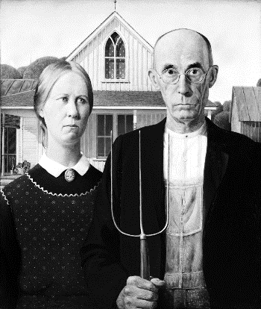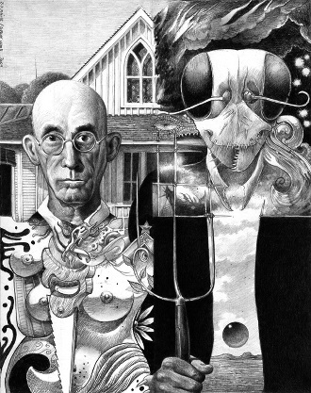

IMPORTANT:
- In order to meet the requirements of AP Art, you must bring with you on the second day of this AP class,(not school), all 5 assignments.
- The Summer Assignment is worth roughly 1/2 of your 1st term grade.
TOTAL:
100 points possible
(Questions can be directed to me at evan.smith@slcschools.org)
(2)

